THE AUTONOMY LADDER · PRACTITIONER GUIDE
Independent Projects · A Catalogue
The Autonomy Ladder · Project Catalogue

Thirty-four projects extracted from the four stage guides, each buildable and assessable on its own.
The stage guides describe four complete systems, sized for a professional: thirty-three engineer-days of platform to reach stage 4. That is the wrong shape for a course, a self-study week, or a two-day exercise. This catalogue cuts the same material into pieces that can be attempted independently.
Each project states what you build, what must already exist, how long it takes, and — most importantly — what has to be demonstrably true for it to be finished. The acceptance criteria are the point: they are countable or checkable by somebody who was not there.
Every project names its source. The build guide section that explains why, the implementation guide section that gives the code, and — where one exists — the numbered walkthrough that shows it running end to end. Read the build guide section first, then attempt the project, then read the implementation guide. Doing it in that order is the difference between building something and copying something.
On the walkthroughs. The implementation guides end with numbered end-to-end traces — W1, W2, W3, W4 — showing a complete run with its span tree and ledger entries. Where a project has one, it is the acceptance test: your implementation should produce that trace. Nine of the thirty-four are anchored this way, and they are the ones to set when you need an unambiguous mark.

How to use this
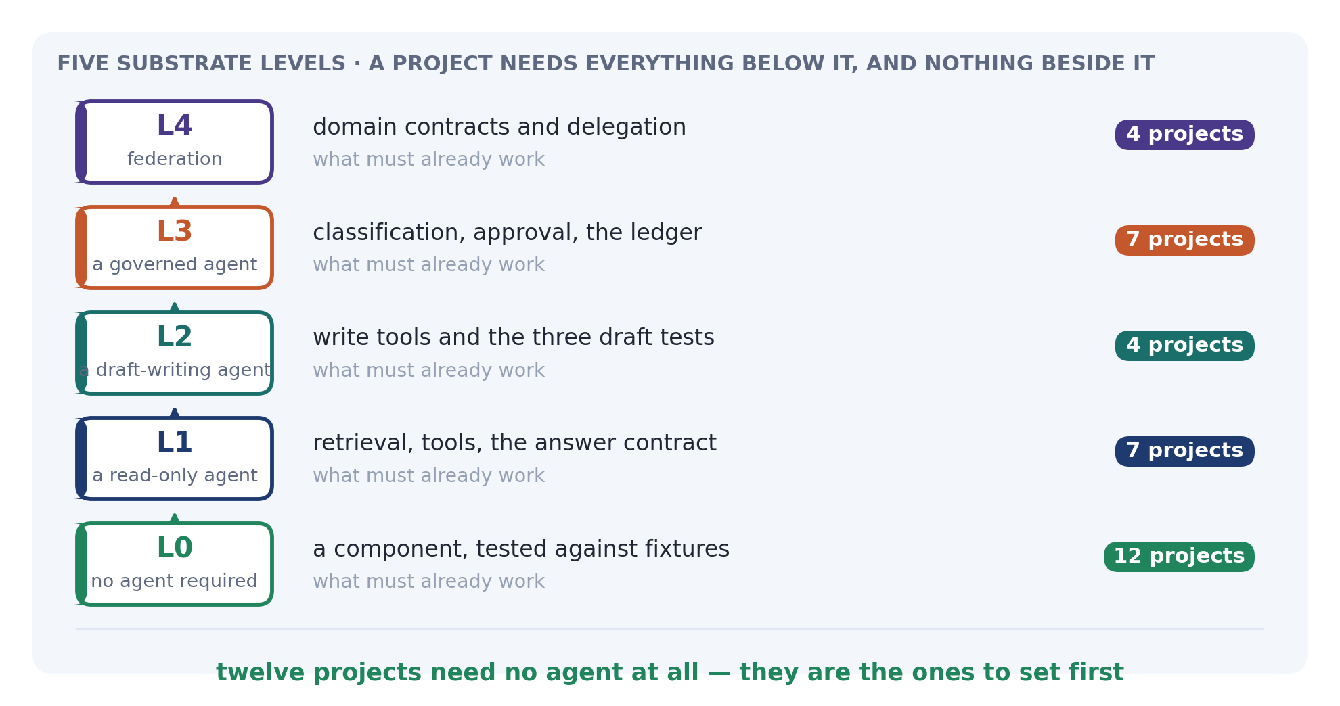
A project needs everything at levels below it and nothing beside it. Twelve projects sit at level 0 and require no agent at all — they are components you build and test against fixtures. Those are the ones to attempt first, and the ones to set as coursework, because a student who cannot get a model responding is not blocked from starting.
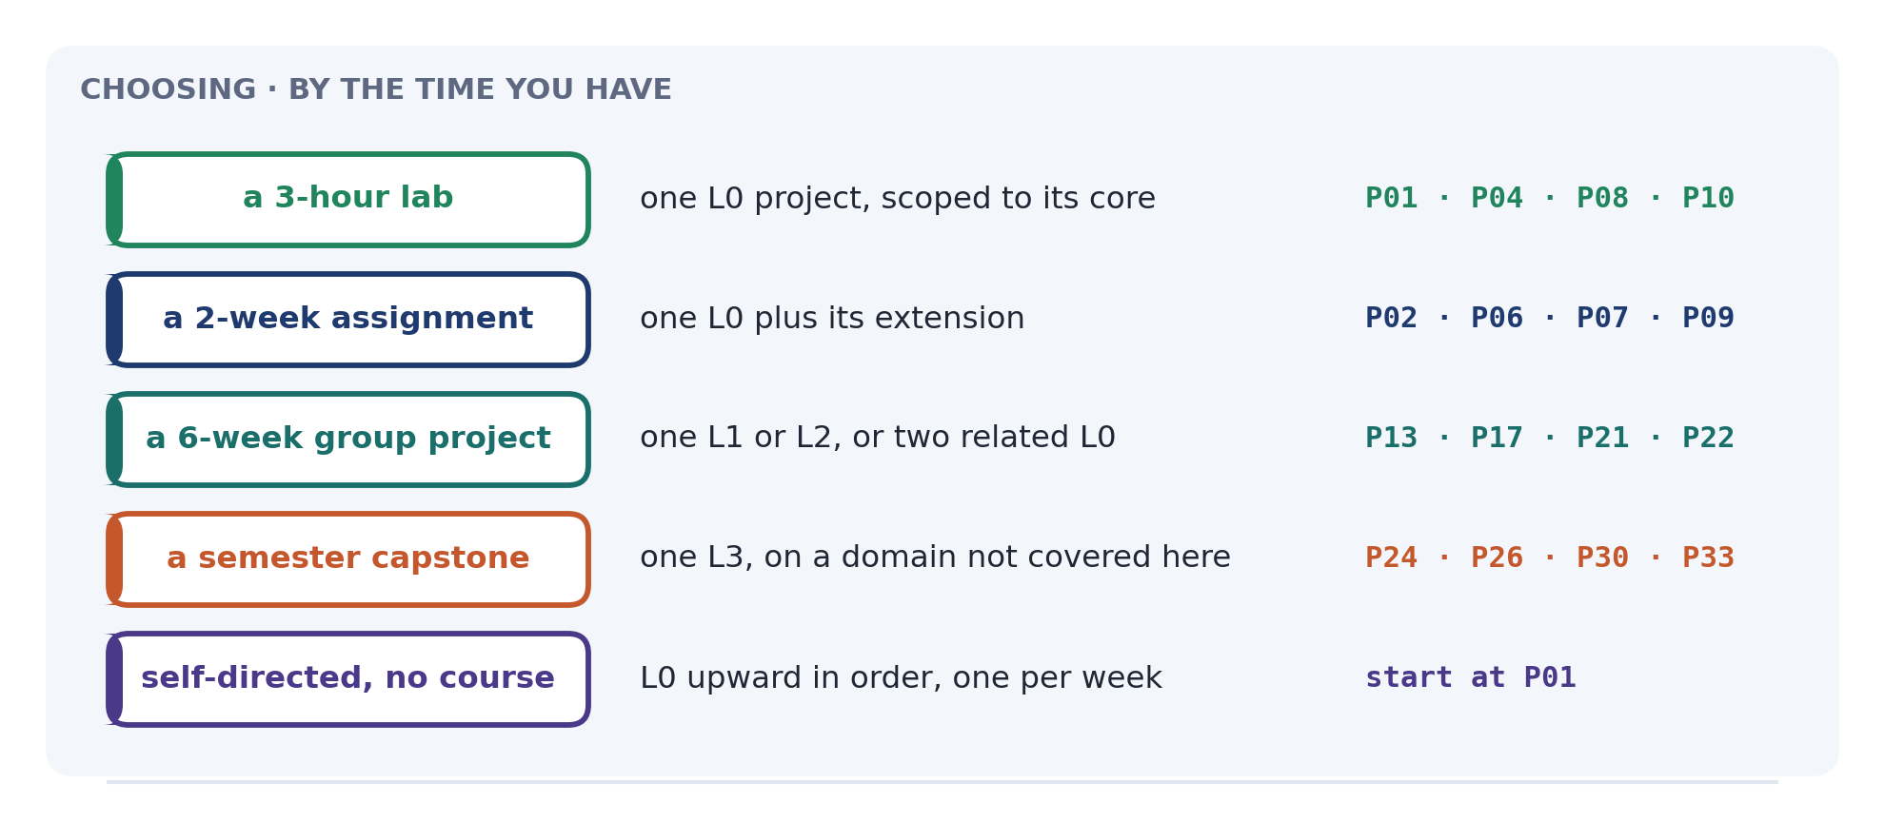
Effort figures assume somebody learning the material, not somebody who already knows it. Halve them for an experienced engineer; do not halve them for a student who is also learning Python.
The traps are real. Each project names the mistake most people actually make. They are there because the fix is cheap once you know and expensive once shipped.

What each guide yields
Guide | Projects | Walkthrough-anchored
Read-Only · Build + Implementation | P01–P05, P11–P16, P18, P19 | —
Draft-Writing · Build + Implementation | P10, P20–P23, P25 | W1 · W2 · W3
Governed · Build + Implementation | P06–P09, P17, P24, P26–P30 | W1 · W2 · W3 · W4
Federated · Build + Implementation | P31–P34 | W1 · W2 · W3

The read-only guide yields the most projects and has no walkthroughs, which is the right shape: its material is components, and its acceptance criteria are measurements — recall, cost, a resolvable citation — rather than traces.
The governed guide yields the hardest ones. P26 alone is worth a fortnight, and its walkthrough W3 is the closest thing in the whole set to an unambiguous mark: four attacks, four specific denial codes, no writes.

Level 0 · No agent required
Twelve components, each testable against fixtures with no model call. The platform (make up, make bootstrap) is the only prerequisite.

P01 · A structural chunker with stable locators
8–12 h
Build. A chunker that splits markdown on headings and clause numbers, falls back to paragraphs above a size limit, treats a fenced code block as atomic whatever its length, and emits locators derived from structure rather than character offsets.
Done when. A 900-token fenced block emerges whole. Editing a paragraph on page 1 leaves every later locator unchanged. A table split across chunks repeats its header in every part.
Source. Read-Only Build Guide §2.2 · Implementation Guide Chunking and Three cases the structural splitter gets wrong · Day 1.
Trap. Splitting inside a fence. Handle it by merging fenced runs before the size loop rather than by adding a branch inside it.

P02 · Contextual retrieval
10–14 h · extends P01
Build. A preprocessing pass that prepends a generated sentence situating each chunk in its document, embeds the combined text, and stores the original separately for citation.
Done when. Retrieval on a query whose terms appear nowhere in the target chunk succeeds. Citations resolve to the original text, not the augmented text. Measured recall improves against a labelled set.
Source. Read-Only Implementation Guide Chunking — this extends what the guide builds rather than replacing it.
Trap. Citing the augmented text. The header is a retrieval aid and must never appear as evidence.

P03 · Hybrid retrieval with rank fusion
10–14 h
Build. A vector arm, a keyword arm, and reciprocal rank fusion over both, with threefold over-fetch and de-duplication by locator.
Done when. A query containing both a concept and an identifier returns chunks matching each. test_hybrid_beats_either_arm passes. Disabling either arm degrades a measured, named query.
Source. Read-Only Build Guide Day 2 · Implementation Guide Fusion and Index tuning.
Trap. Fusing by score. A cosine and a ts_rank are not commensurable; use ranks.

P04 · A labelled set and a recall harness
6–8 h
Build. Thirty labelled queries keyed by (source, locator), each naming the caller, including at least three expected to return nothing. A harness reporting recall@4, @8 and @16 per arm and fused.
Done when. The harness runs in under a minute, reports per-query as well as mean recall, and correctly scores a query whose expected result is empty.
Source. Read-Only Build Guide Day 6 · Implementation Guide §10, the evaluation harness.
Trap. Labelling by text. Re-chunk and the whole set is void.

P05 · An entitlement rule engine
6–8 h
Build. An ordered rule set mapping document paths to entitlement sets, with first-match-wins semantics, no permissive default, and an import-time assertion that rules are ordered most-specific-first.
Done when. A document matching no rule fails ingestion and lands in a queue. Appending a general rule above a specific one fails the build. A test proves board minutes do not become visible to the whole finance department.
Source. Read-Only Build Guide §2.4 · Implementation Guide Assigning entitlements.
Trap. A default of {employee}. Every misfiled document is then published silently.

P06 · A canonical serialiser and payload hasher
6–10 h
Build. A canonicaliser producing byte-identical output for equivalent payloads: sorted keys, decimals as strings, datetimes normalised to UTC, sets sorted, and floats refused.
Done when. The same object serialised on two machines hashes identically. Key order does not affect the hash. A float raises with a message naming Decimal. A round-trip through JSON preserves the hash.
Source. Governed Build Guide Canonical serialisation · Implementation Guide §4.
Trap. Allowing floats "just this once". The mismatch appears later, is unreproducible, and the tempting fix deletes the control.

P07 · A hash-chained ledger
8–12 h
Build. An append-only table with prev_hash and entry_hash, an append function taking a lock on the head read, a verifier reporting the first divergence, and an anchoring job publishing the head to storage under a different credential.
Done when. Seed 2,000 entries; alter one; the verifier names the exact sequence and the count invalidated. Recompute the whole chain; verification passes and the anchor comparison fails.
Source. Governed Build Guide §2.6 and The ledger · Implementation Guide §6.
Trap. Omitting FOR UPDATE on the head read. The chain forks under concurrency and verification fails at an apparently random point — reported as "the ledger is flaky".

P08 · A schema fuzzer with a canary
6–8 h
Build. A property-based harness generating a thousand payloads per tool, asserting that no input reaches a handler without conforming to the declared schema — plus a deliberately-permissive canary tool proving the harness can fail.
Done when. The canary produces bypasses. Real tools produce none, or the ones it finds are fixed and become named regression tests. The seed is printed on failure.
Source. Governed Build Guide §2.7 · Implementation Guide the harness, days 10–11.
Trap. Believing a clean first run. Add the canary before believing anything.

P09 · A permission matrix generator
5–7 h
Build. A generator producing the role × tool matrix by simulation, a differ against a committed expectation, and a CI check that fails on an unacknowledged cell.
Done when. Adding a tool fails the build until the matrix is updated. The rendered matrix fits on one page. The diff appears in the pull request body, not only in a log.
Source. Governed Build Guide §2.7 · Implementation Guide the permission matrix.
Trap. Running it and not reading it. A diff nobody sees is not a control.

P10 · An idempotency store
6–8 h
Build. A two-phase key store — mark attempted before the call, mark completed after — with a recovery path that queries the target system rather than assuming, and a key derived from intent rather than from the attempt.
Done when. Killing the process between the call and the completion mark, then retrying, produces one effect and not two. A key containing a timestamp is rejected by a test.
Source. Draft-Writing Build Guide §2.4 · Implementation Guide Two-phase writes (elaborated in the Governed guide).
Trap. No external reference in the target system. Without it, recovery cannot ask whether the effect happened, and the honest answer becomes an operator decision.

P11 · A cost meter with per-step attribution
5–7 h
Build. Span attributes for role, model, tokens in and out, and cost; a per-node breakdown; and a counterfactual computing what a run would have cost with every step on one model.
Done when. A run's cost is attributable to a node, not just a total. The counterfactual runs nightly against a fixed fixture. Local inference is priced at an amortised rate rather than zero.
Source. Read-Only Implementation Guide Cost meter and Span shape.
Trap. Pricing local inference at zero. A structurally zero column makes every comparison meaningless.

P12 · A prompt loader with expiry
4–6 h
Build. Prompts as versioned files with front matter — version, role, owner, last regression date, changelog — loaded by role, with a staleness check that fails the build and warns at runtime.
Done when. A prompt not regressed in ninety days fails CI. The version appears in every trace. A prompt change is a reviewable diff.
Source. Read-Only Implementation Guide §8.1, Prompts are versioned artifacts.
Trap. Failing at runtime rather than at build. An import-time failure during an incident is an outage for an unrelated reason.

Level 1 · Needs a read-only agent
Seven projects assuming retrieval, typed read tools, and an answer contract already work.

P13 · A typed tool set and a manifest
10–14 h
Build. Three read tools with extra="forbid" input models, pattern-constrained identifiers, row limits with truncation flags, and a decorator performing five checks at import. Plus a manifest generated from the registry and diffed in CI.
Done when. A tool without a description or a row limit cannot be registered. make manifest fails if the committed file differs. A malformed argument never reaches a handler.
Source. Read-Only Build Guide §2.1, §2.6 and Day 4 · Implementation Guide Adapters.
Trap. \d in an identifier pattern. It matches Devanagari and fullwidth digits; use [0-9].

P14 · The answer contract with a declined path
8–12 h
Build. A typed answer with kind, findings each carrying at least one evidence reference, considered_and_rejected, scope_limits written by code, truncated_sources, and missing_sources — plus validators making inconsistent shapes unrepresentable.
Done when. A question the corpus cannot answer produces declined with an empty findings list and a populated missing_sources. kind="answered" with truncation raises.
Source. Read-Only Build Guide §2.7 and Day 3 · Implementation Guide Provenance out and §8.2.
Trap. Letting the model write scope_limits. It will invent plausible limitations, indistinguishable from real ones.

P15 · A citation resolver and aligner
6–8 h
Build. A resolver turning an evidence reference back into the chunk it cites, a test asserting every citation in a sample resolves, and an aligner correcting near-misses against the offered set while raising on inventions.
Done when. A locator shortened from §2.1 to §2 is corrected. A locator naming a document that was never retrieved raises. Re-chunking the corpus is followed by a re-run over recent answers.
Source. Read-Only Build Guide §2.3 · Implementation Guide Provenance out and §8.4, the entailment prompt.
Trap. Treating a near-miss as a failure. It is the commonest case and it is correctable.

P16 · Safe follow-up handling
8–10 h
Build. Follow-up rewriting into standalone questions, a two-turn history cap, an is_followup pass-through, and per-turn caller identity in the session store.
Done when. In a shared session, a second user's follow-up returns nothing the first user's entitlements uniquely permitted. The rewritten question is shown to the user.
Source. Read-Only Build Guide Day 5 and Day 6 · Implementation Guide §9.
Trap. Carrying the previous turn's retrieved chunks forward. It is faster, users prefer it, and it is an access-control defect.

P17 · A graph executor with reducers
12–16 h
Build. A sixty-line executor over declared nodes and edges, with typed state, per-key reducers, compile-time rejection of multi-writer keys lacking one, a runtime recursion limit, and checkpointing after each node.
Done when. Three concurrent workers writing one key produce the same count across twenty runs. A graph with an unreduced multi-writer key fails to compile. A killed process resumes from its last checkpoint.
Source. Governed Build Guide Checkpointing and the crash window · Implementation Guide §5.
Trap. Testing once. Without a reducer the correct answer appears roughly one run in five.

P18 · A router
6–8 h
Build. A classification into a closed set, a routing table mapping each category to a workflow, and a low-confidence path to human review.
Done when. An unrecognised category is unrepresentable rather than handled. The routing table is readable by somebody who cannot read Python. Classification accuracy is measured against a labelled set.
Source. Read-Only Build Guide Day 5 · Implementation Guide §8.3, the planning prompt.
Trap. Letting the model compose the plan instead of selecting from a table.

P19 · A model profile switcher and portability benchmark
10–14 h
Build. Role-to-model profiles with no node naming a model, and a benchmark reporting governance assertions, functional assertions, latency and cost across three profiles.
Done when. Governance assertions are identical across all three. The report prints its own failures. Swapping the entire cognitive layer is one file.
Source. Read-Only Implementation Guide Model configuration · Governed Implementation Guide The five metrics.
Trap. A benchmark with no failures. Plant a known-hard case and confirm it fails.

Level 2 · Needs a draft-writing agent

P20 · The three draft tests, per system
8–12 h
Build. A parameterised harness verifying, for each target system, that a human action is required, that discarding leaves no audit footprint, and that nothing downstream fired.
Done when. The suite runs against two systems. audit_footprint captures sequence numbers, audit rows and outbound events. A fixture that emits an event fails test 3.
Source. Draft-Writing Build Guide The three tests applied · Implementation Guide Verifying the three draft tests, per system.
Trap. Checking the object's state rather than its side effects. A vendor upgrade that shares drafts with a portal passes a state check and fails reality.

P21 · A semantic verification layer
8–10 h
Build. Read-back verification asserting the object exists, is in the expected state, holds the requested values, and is attached to the right parent — with a bounded poll for eventually-consistent backends.
Done when. Three stubbed misbehaviours are caught: returns an id and stores nothing, creates in the wrong state, coerces an amount. The consistency window is declared per backend.
Source. Draft-Writing Build Guide §2.3 · Implementation Guide Semantic checks, and the state assertion.
Trap. assert result is not None. That tests your client library, not the world.

P22 · A draft lifecycle tracker
10–14 h
Build. A draft table with terminal states, a reconciliation poller against each target system, a diff between what was proposed and what was converted, and time-to-convert metrics.
Done when. A draft converted with edits is recorded as converted_edited with the field-level diff. An abandoned draft expires rather than sitting open forever.
Source. Draft-Writing Build Guide Recording the draft, Detecting conversion, Capturing the edit · Implementation Guide The webhook path and The diff.
Trap. Recording only conversions. The discards and the edits are the signal.

P23 · Conversion metrics that detect rubber-stamping
5–7 h
Build. The metric pair: conversion rate alongside time-to-convert and edit rate, with an assertion that median time-to-convert exceeds a floor.
Done when. A simulated queue-clearing pattern fails the assertion while the conversion rate still looks healthy.
Source. Draft-Writing Build Guide §2.6, Conversion as the control · Implementation Guide Metrics.
Trap. Reporting the rate alone. It is identical for excellent drafts and for nobody reading them.

Level 3 · Needs a governed agent

P24 · A risk rubric and classifier
12–16 h
Build. Scope × reversibility × persistence with both overrides, a policy-pin registry with expiry, dynamic rubrics that vary by payload, and obligation fields checked after the rubric resolves.
Done when. Every route to category 4 has a test. A pin past its review date appears in a report. Two engineers scoring the same operation independently agree, or the disagreement is recorded as a note.
Source. Governed Build Guide §2.1–2.3 and The rubric in code, Dynamic classification, Policy pins · Implementation Guide Static and dynamic rubrics, Pins.
Trap. Checking obligation fields during schema validation. They must be checked after the rubric decides which apply.

P25 · Boundary functions with policy provenance
8–12 h
Build. Boundaries reading limits from policy at call time, returning both the denial and its citation, with a gap record where no policy exists and a report counting gaps by firing frequency.
Done when. A denial names a clause and an effective date. A boundary with no policy cites a gap naming its owner. No limit is a constant in code.
Source. Draft-Writing Build Guide §2.2, Boundaries, with provenance · Implementation Guide Policy loading, so boundaries never hold constants.
Trap. Inventing a limit and shipping it as though it were policy.

P26 · The approval protocol, attacked four ways
16–20 h · the strongest single project in the catalogue
Build. Canonicalisation, hashing, suspension with checkpointing, notification by claim, a token carrying both the payload hash and the approval id, resume with a row lock and two hash comparisons, four-eyes enforcement, and boundaries re-run at resume.
Done when. All four attacks are demonstrated and refused: tamper, replay across two identical approvals, expiry, self-approval. Two simultaneous approvals produce one effect. An approval valid on Monday is refused on Thursday because the world moved.
Source. Governed Build Guide §2.4, Suspend and resume, Plan-as-payload, Batch presentation is not batch governance · Implementation Guide walkthrough W3, the approval protocol under attack.
Trap. Binding only the payload hash. Two genuinely identical actions then share a signature, which is exactly the shape of a duplicate-payment fraud.

P27 · Durable execution and suspension
12–16 h
Build. A workflow that suspends for human approval and survives process restarts and deployments, with a bounded time-to-live and an expiry path.
Done when. Restarting every service while a workflow waits does not lose the suspension. An approval arriving after the TTL is refused with a distinct code.
Source. Governed Build Guide §2.5 and Checkpointing and the crash window · Implementation Guide walkthrough W2.
Trap. Holding the wait in memory. It works in development and loses every pending approval on the first deployment.

P28 · A compensation engine
10–14 h
Build. Sagas with per-step compensators, applied in reverse order, and a declaration per workflow of whether partial completion is worse than rollback.
Done when. A provisioning workflow failing at step four leaves zero residual artifacts. A revocation workflow failing at step three does not roll back, reports partial completion, and names the residual.
Source. Governed Build Guide Multi-system writes and When a compensator fails · Implementation Guide Sagas.
Trap. Compensating a revocation. Rolling back re-grants the access you were removing.

P29 · An injection suite asserting on effects
12–16 h
Build. Fixtures for eight injection families as data rather than code, planted in seeded records, asserting no unauthorised effect and that the hostile text remains visible in the trace.
Done when. Disabling each defence layer in turn shows a different layer catching the same injection. The suite asserts effects, never refusals. Every tool has at least one fixture.
Source. Governed Build Guide §2.7 · Implementation Guide the injection suite, days 10–11.
Trap. Asserting model_refused. It fails on the next model upgrade for reasons unrelated to safety.

P30 · Progressive exposure with evidence packs
10–14 h
Build. Five stages with checkable gates, a promotion command refusing without a linked evidence run, automatic demotion on any harness failure, and generated evidence packs.
Done when. Promotion without evidence is refused with a message naming the unmet gate. A simulated harness failure demotes one stage automatically. The pack includes denials, approval decision times, and an approver survey.
Source. Governed Build Guide the exposure ladder, day 12 · Implementation Guide walkthrough W4.
Trap. Requiring approval to demote. The whole asymmetry is that demotion is automatic and the argument happens afterwards.

Level 4 · Federated

P31 · An agent capability registry with will-not enforcement
10–14 h
Build. Versioned capability declarations per domain, a will_not list, a resolver detecting staleness, and a test asserting every will_not entry maps to a check the domain actually runs.
Done when. A coordinator plans against declared capabilities rather than discovering refusals at execution. A will_not entry with no corresponding check fails the build.
Source. Federated Build Guide §2.2–2.3, The registry, will_not is enforced · Implementation Guide Serving and fetching, will_not checks read only the domain's own data.
Trap. Treating will_not as documentation. It is enforced, or it is a lie with a version number.

P32 · Token exchange and the delegation chain
10–14 h
Build. Per-domain, per-call token exchange producing tokens whose subject is the user and whose actor is the coordinator, with the domain verifying both.
Done when. A token exchanged for domain A is rejected by domain B. A domain refuses a request whose actor is not permitted to act for that subject, even when the subject is entitled.
Source. Federated Build Guide §2.4, Token exchange, Two-sided verification · Implementation Guide Domain-side verification · walkthrough W1.
Trap. Forwarding the original token. That is a confused deputy, and it is one line to prevent.

P33 · Cross-domain planning with one approval
14–18 h
Build. A dry-run plan phase across domains, a consolidated plan hashed as one object, a single human approval covering all of it, and fan-out execution bound to that approval.
Done when. One approver signs once for a four-domain operation. A domain still refuses at execution if its policy changed after approval — and the refusal is reported rather than overridden.
Source. Federated Build Guide §2.5–2.6, The envelope, One human gate over many domains · Implementation Guide Envelope verification, domain side · walkthrough W2.
Trap. Approving per domain. The approver then cannot see the whole operation, which is the thing they were asked to judge.

P34 · Two-perimeter evidence and honest partial reporting
10–12 h
Build. A correlation identifier propagated across every domain, evidence assembled from several ledgers, and a report stating precisely what completed, what did not, and why.
Done when. A run touching four domains reconstructs across four ledgers. A partial completion names the residual with its citation and schedules a follow-up. Nothing is claimed that did not happen.
Source. Federated Build Guide §2.7, Partial completion across domains, Five metrics · Implementation Guide walkthrough W3.
Trap. Reporting success when three of four domains succeeded.

Assessment notes
Every acceptance criterion above is checkable by somebody who was not present. That is deliberate, and it is what makes these assessable at scale.
Suggested weighting, for a project used as coursework:
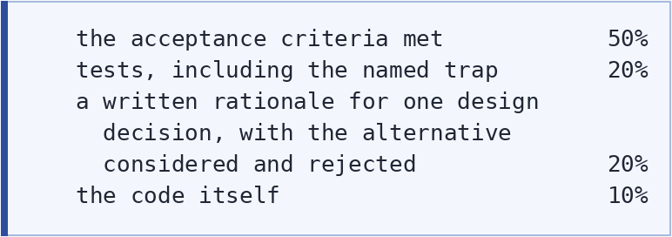
The third line matters more than its weight suggests. A student who built P26 and can explain why the approval token binds two values rather than one has learned the thing; a student who copied a working implementation has not, and the rationale is where the difference shows.
On the trap in each project: name it in the brief, or do not. Naming it turns the project into an exercise in following instructions; withholding it turns the same project into an exercise in debugging, and the second is more valuable if the marking scheme forgives it.

Appendix · Coverage by guide section
What this is for. If you are setting coursework from one guide, this tells you which of its sections have a project attached and which do not. A section with no project is not an oversight — some are argument rather than construction — but it is worth knowing which parts of a guide a student will not have built.

Read-Only
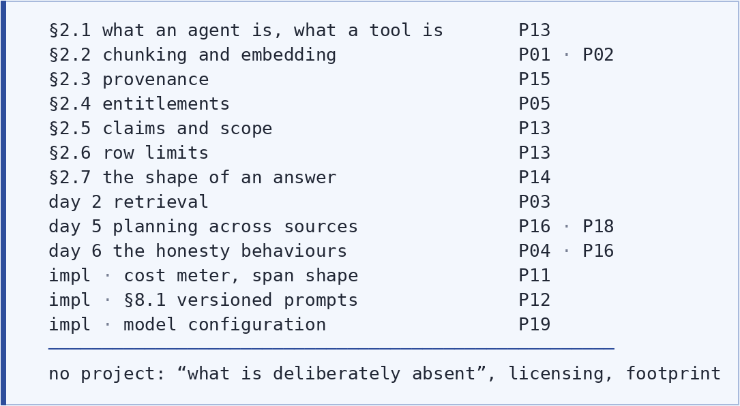

Draft-Writing
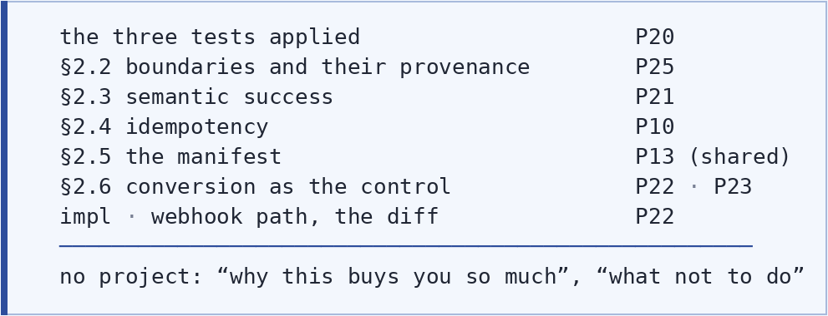

Governed
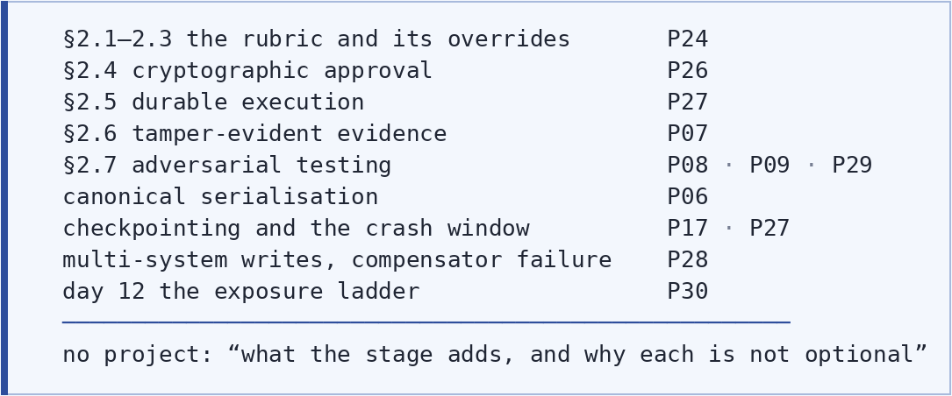

Federated
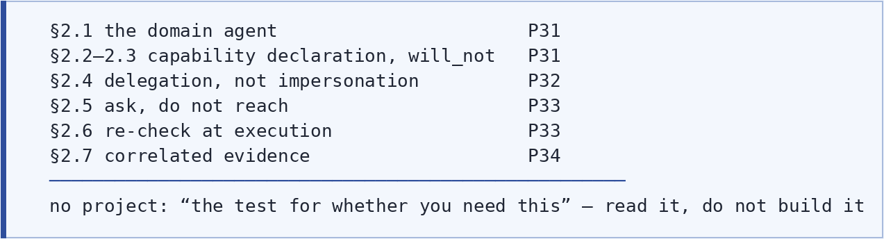
One observation from assembling this. The sections without projects are, almost without exception, the ones arguing whether to build the stage at all — the introduction's where to stop, the read-only guide's what is deliberately absent, the federated guide's the test for whether you need this.
That is deliberate on the guides' part and worth preserving. A student who builds every project and skips those sections will know how and not whether, and the second judgement is the harder one. Set at least one of those sections as reading alongside whichever project you assign.

References
- Building a Read-Only Enterprise Agent and Read-Only Agent — Implementation Guide. The Autonomy Ladder, stage 1.
- Building a Draft-Writing Enterprise Agent and Draft-Writing Agent — Implementation Guide. Stage 2.
- Building a Governed Enterprise Agent and Governed Agent — Implementation Guide. Stage 3.
- Building a Federated Enterprise Agent and Federated Agent — Implementation Guide. Stage 4.
- The Autonomy Ladder: An Introduction. — read before selecting a project, particularly §10, where to stop.

